CLASS X
MATHEMATICS
Introduction to Trigonometry
Worksheet (Module 3/3)

Prove the following identities:
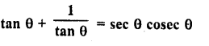
1. (Sec² θ – 1) (Cosec² θ – 1) = 1
Solution:
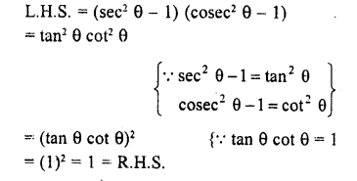
2.
Solution: Taking L.H.S
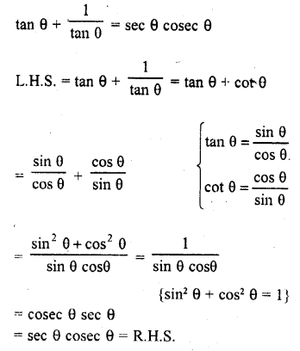
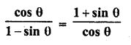
3.
Solution: Taking L.H.S
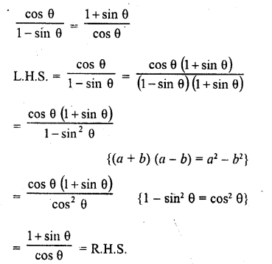
Prove the following trigonometric identities:
1. (1 – cos² A) cosec² A = 1
2. (1 + cot² A) sin² A = 1
3. cosec θ √(1 – cos² θ) = 1
4. tan θ + 1/ tan θ = sec θ cosec θ
5. sin² A + 1/(1 + tan ² A) = 1
6. (1 – sin θ) / (1 + sin θ) = (sec θ – tan θ)²
7. tan² θ − sin² θ = tan² θ sin² θ
8. (sec θ + cos θ) (sec θ – cos θ) = tan² θ + sin² θ
9. (cos² θ/ sin θ) – cosec θ + sin θ = 0
10. Show that
$$\frac{\operatorname{cosec}{A}}{\operatorname{cosec}{A-1}}+ \frac{\operatorname{cosec}{A}}{\operatorname{cosec}{A+1}}{=2\sec^{2}A}$$

